**Project Development Phase**

**Sprint 4**

|  |  |
| --- | --- |
| Date | 12 November 2022 |
| Team ID | PNT2022TMID41225 |
| Project Name | Global Sales Data Analytics |

**Sprint 4 tasks:**

* Creating web application
* Embedding Dashboard to web application
* Embedding Report to web application
* Embedding Story to web application

**Creating web application:**

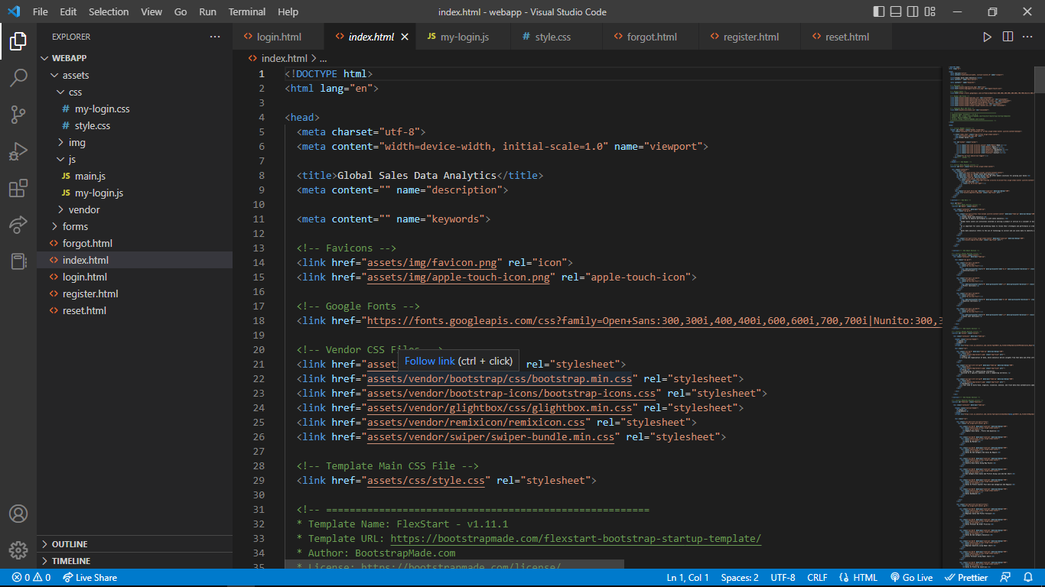

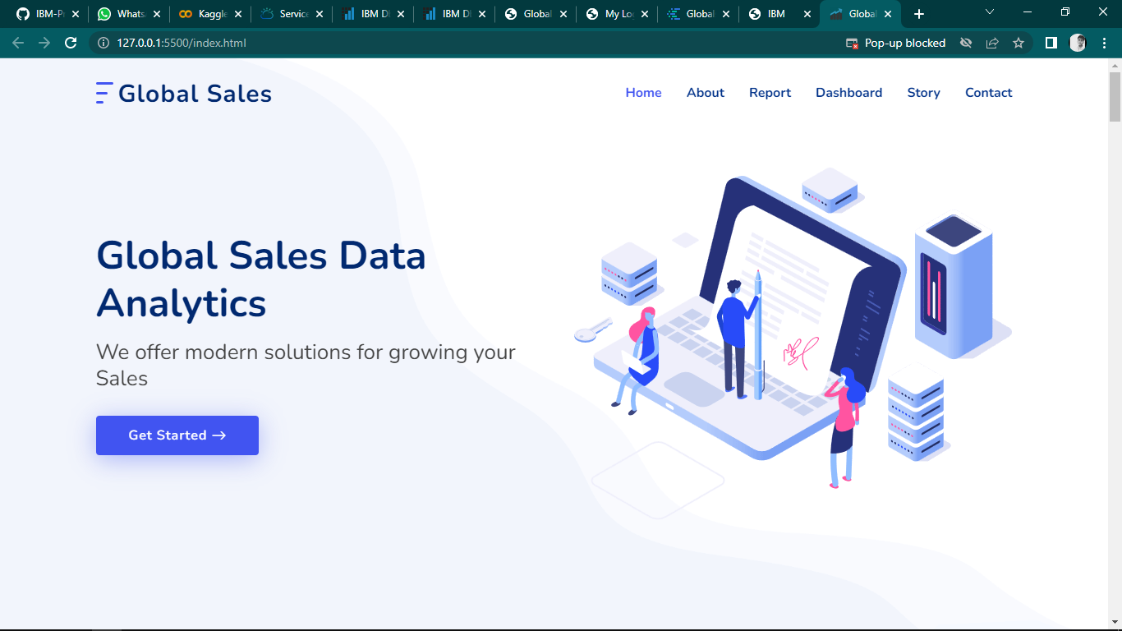

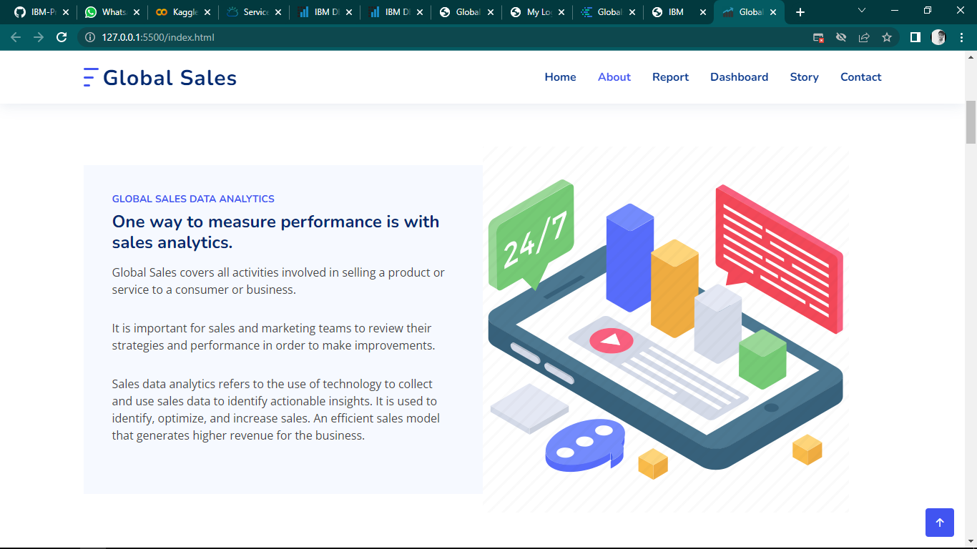

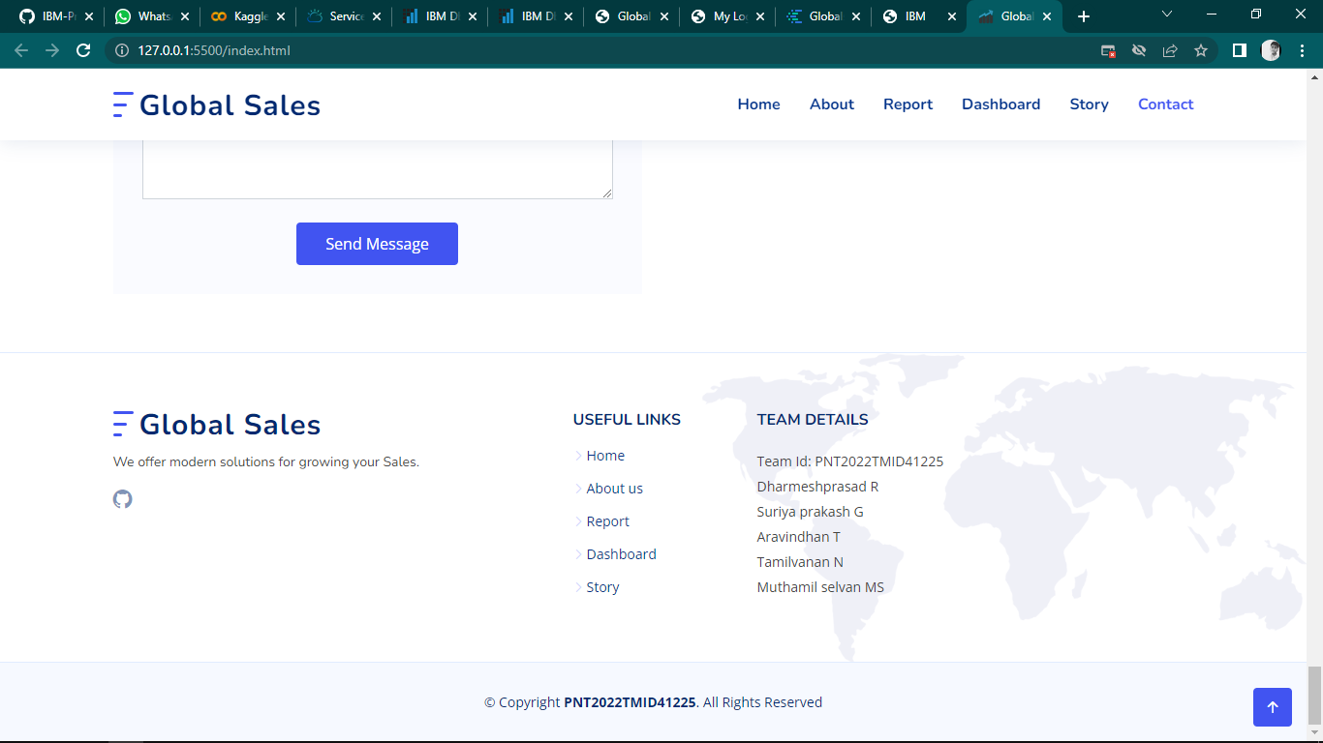

**Embedding Dashboard to web application:**

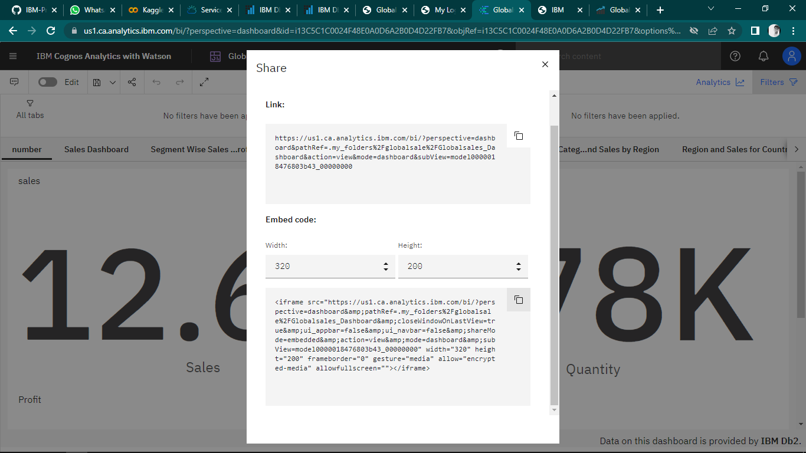

**Link:**

https://us1.ca.analytics.ibm.com/bi/?perspective=dashboard&pathRef=.my_folders%2Fglobalsale%2FGlobalsales_Dashboard&action=view&mode=dashboard&subView=model0000018476803b43_00000000

**Embedding Report to web application:**

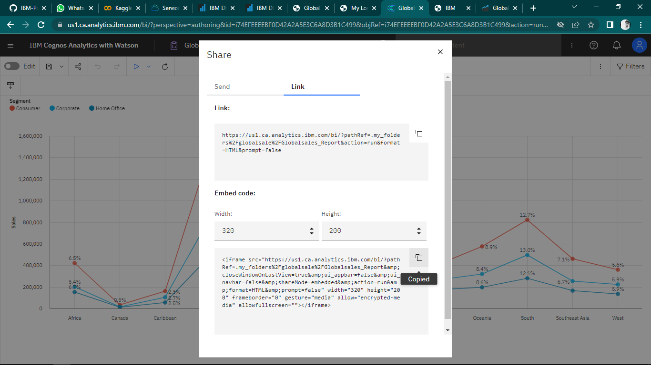

**Link:**

https://us1.ca.analytics.ibm.com/bi/?pathRef=.my_folders%2Fglobalsale%2FGlobalsales_Report&action=run&format=HTML&prompt=false

**Embedding Report to web application:**

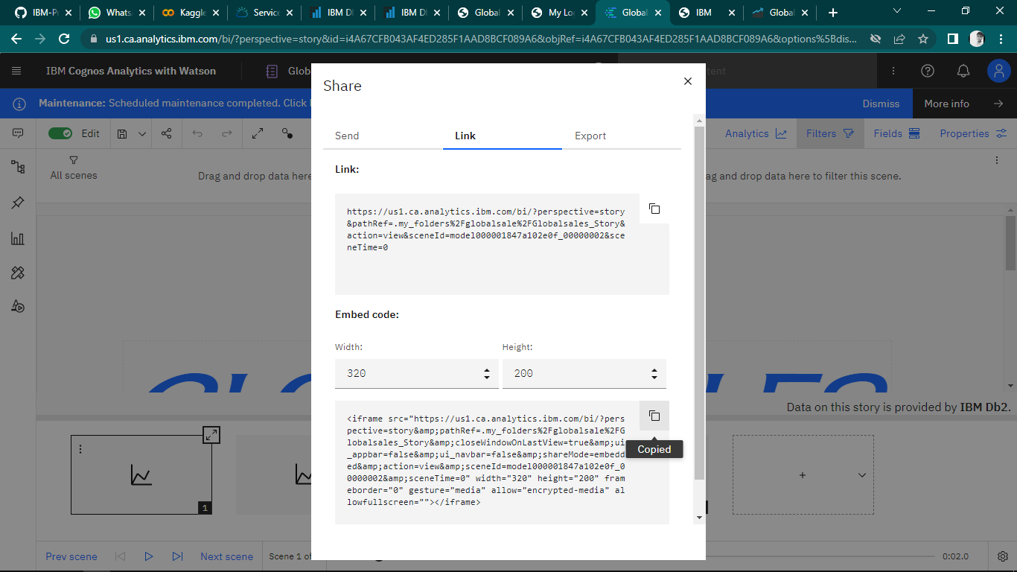

**Link:**

https://us1.ca.analytics.ibm.com/bi/?perspective=story&pathRef=.my_folders%2Fglobalsale%2FGlobalsales_Story&action=view&sceneId=model000001847bbb44a0_00000000&sceneTime=6000